Autoregressive Inverse Design of Disordered Metamaterials for Target Nonlinear Response
Dazhi Zhao¹#, Yujie Xiang², Peng Zhang¹, and Keke Tang¹*
¹School of Aerospace Engineering and Applied Mechanics, Tongji University, Shanghai, China
²Department of Mechanical Engineering, Carnegie Mellon University, Pittsburgh, USA

*Corresponding author: kktang@tongji.edu.cn
# Presenter: zhaodazhi@ tongji.edu.cn

The inverse design of disordered metamaterials to achieve a target nonlinear response is a significant challenge, primarily due to the difficulty of ensuring global connectivity—a problem sidestepped in periodic systems by their unit-cell-based design. Current research is consequently divided: methods capable of designing for complex nonlinear responses are limited to simple, periodic structures, while the exploration of disordered structures is hampered by the unsolved connectivity issue and is restricted to designing for simple mechanical properties. To bridge this gap, we propose a novel data-driven framework. We use an Autoregressive model for the inverse design, leveraging its powerful conditional generation to be guided by the target nonlinear response while simultaneously learning the implicit growth rules to ensure structural validity. This is coupled with a Fourier Neural Operator as a high-performance surrogate model for rapid and accurate forward prediction. This closed-loop framework aims to efficiently solve the challenge of designing disordered metamaterials with a precisely tailored nonlinear response.

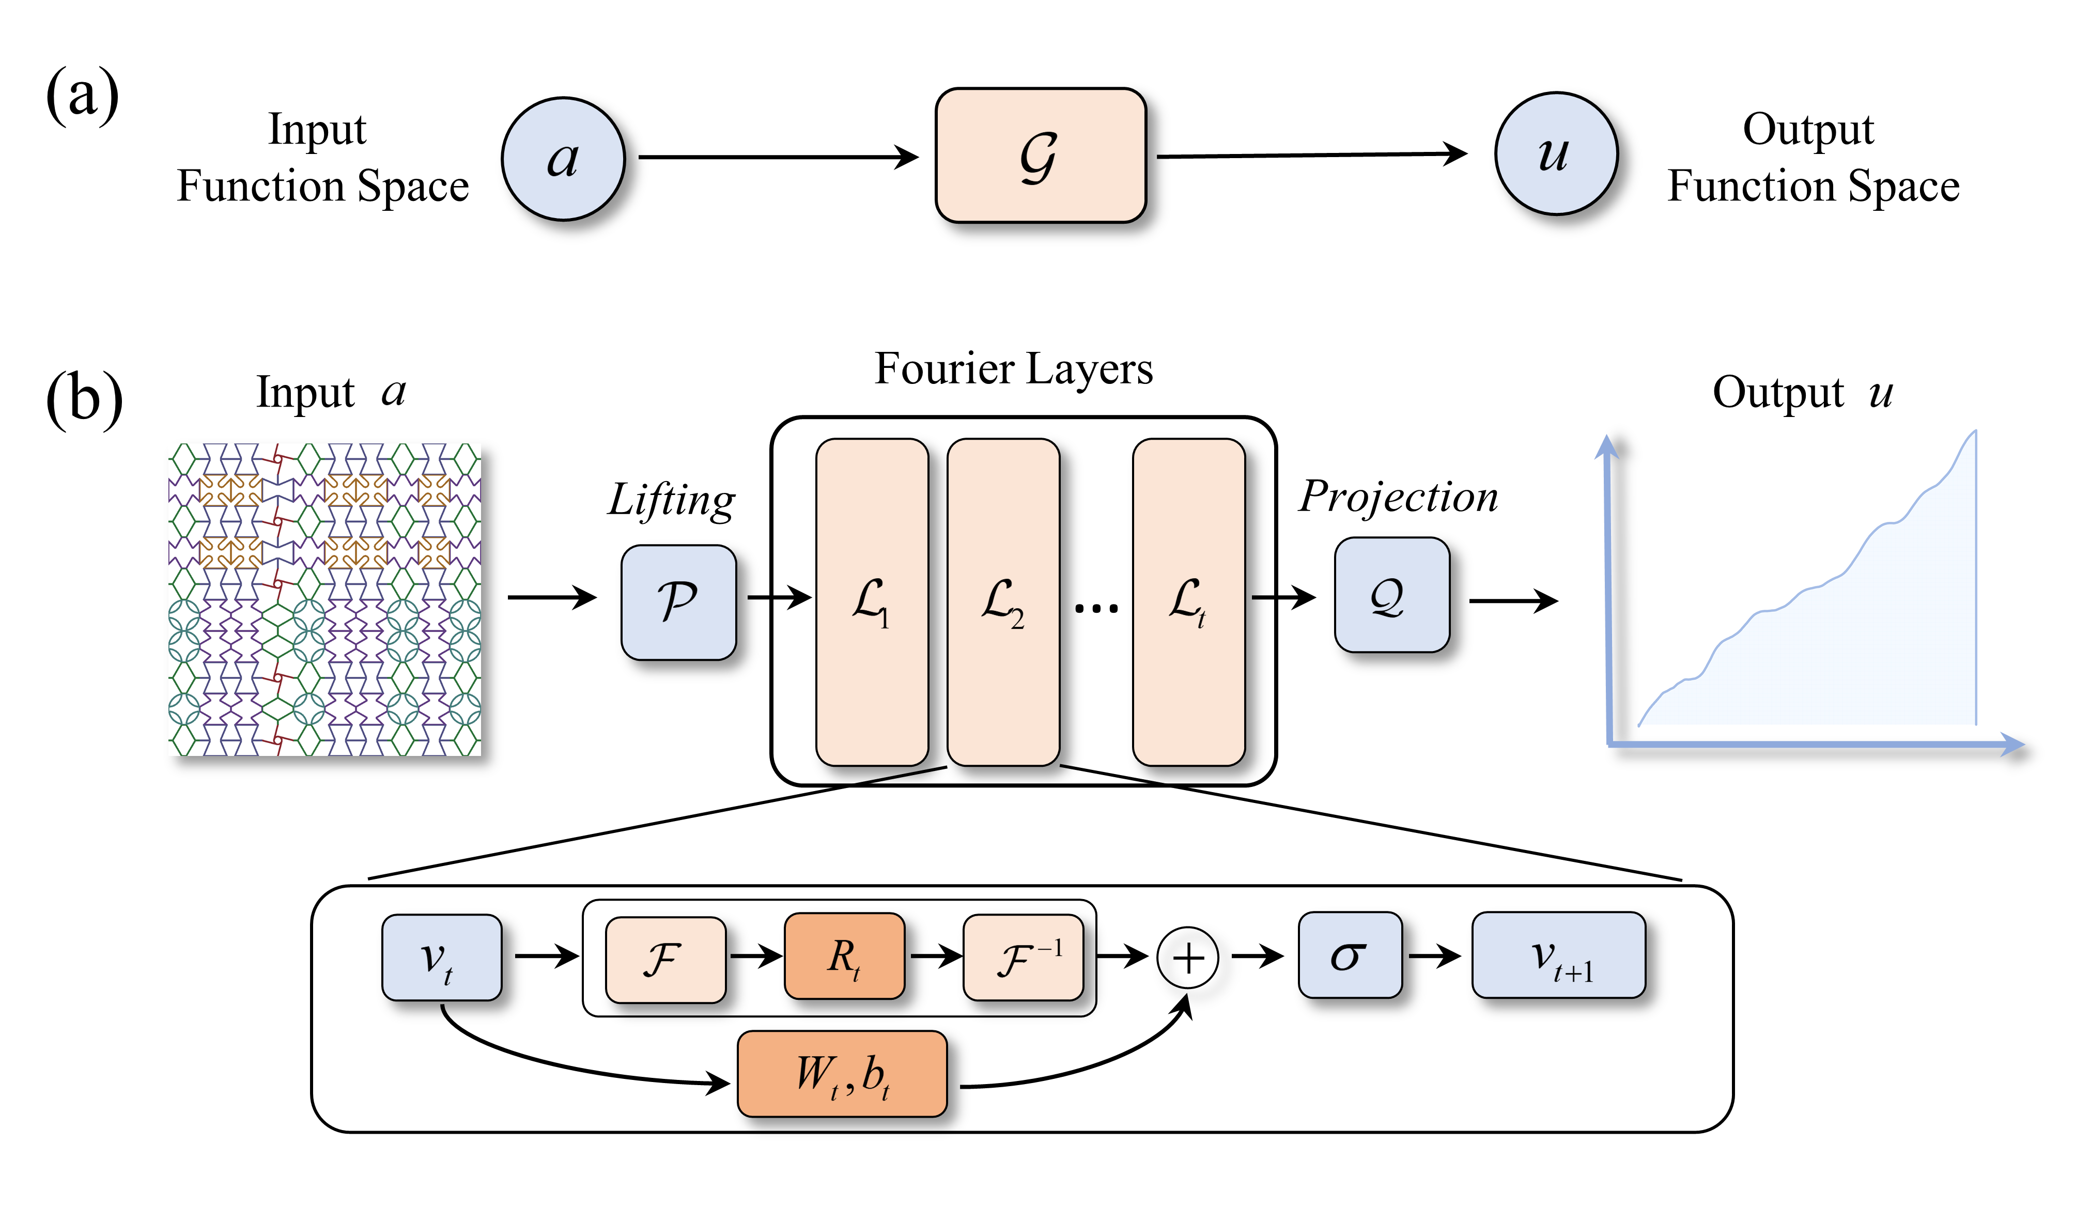
Figure 1.Architecture of Fourier Neural Operator.

References
Lee D, Chen W, Wang L, et al. Data‐driven design for metamaterials and multiscale systems: a review[J]. Advanced Materials, 2024, 36(8): 2305254.
Liu K, Sun R, Daraio C. Growth rules for irregular architected materials with programmable properties[J]. Science, 2022, 377(6609): 975-981.
Bastek J H, Kochmann D M. Inverse design of nonlinear mechanical metamaterials via video denoising diffusion models[J]. Nature Machine Intelligence, 2023, 5(12): 1466-1475.
Wei Z, Wei K, Yang X. Inverse design of irregular architected materials with programmable stiffness based on deep learning[J]. Composite Structures, 2024, 340: 118210.
Zhou Y H, Zheng Y F, Zhang Y Q, et al. Inverse design of growth-inspired irregular architected materials for programmable properties[J]. Extreme Mechanics Letters, 2024, 70: 102196.
Naghavi Khanghah K, Wang Z, Xu H. Generating Porous Metamaterial Designs Using Variational Graph Autoencoder and Large Language Model[C]//International Design Engineering Technical Conferences and Computers and Information in Engineering Conference. American Society of Mechanical Engineers, 2024, 88360: V03AT03A007.
Wang Z, Bray A, Naghavi Khanghah K, et al. Designing Connectivity-Guaranteed Porous Metamaterial Units Using Generative Graph Neural Networks[J]. Journal of Mechanical Design, 2025, 147(2): 021706.
Xiang Y, Hou J, Chen X, et al. Decoupled Design of Hybrid Mechanical Metamaterials via Ensembled Deep Learning[J]. International Journal of Mechanical Sciences, 2025: 110514.
Jin H, Zhang B, Cao Q, et al. Characterization and Inverse Design of Stochastic Mechanical Metamaterials Using Neural Operators[J]. Advanced Materials, 2025: 2420063.

